BÏEJH TEEKSTEM JÏH GUVVIEM

Tsïengele
Måanta | Dæjsta | Gaskevåhkoe | Duarsta | Bearjadahke | Laavvadahke | Aejlege
 |  |  | 1  Voestes orrejaepiebiejjie | 2 | 3 | 4
5 | 6  Bissiebiejjie Sveerjesne, Soemesne | 7 | 8 | 9 | 10 | 11
12 | 13 | 14 | 15 | 16 | 17 | 18
19 | 20 | 21 | 22 | 23 | 24 | 25
26 | 27 | 28 | 29 | 30 | 31

Bija gova ja teavstta
BÏEJH TEEKSTEM JÏH GUVVIEM
Bieja gåvåv ja tevstav

BÏEJH TEEKSTEM JÏH GUVVIEM

Goevte
Måanta | Dæjsta | Gaskevåhkoe | Duarsta | Bearjadahke | Laavvadahke | Aejlege
 |  |  |  |  |  | 1
2 | 3 | 4 | 5 | 6 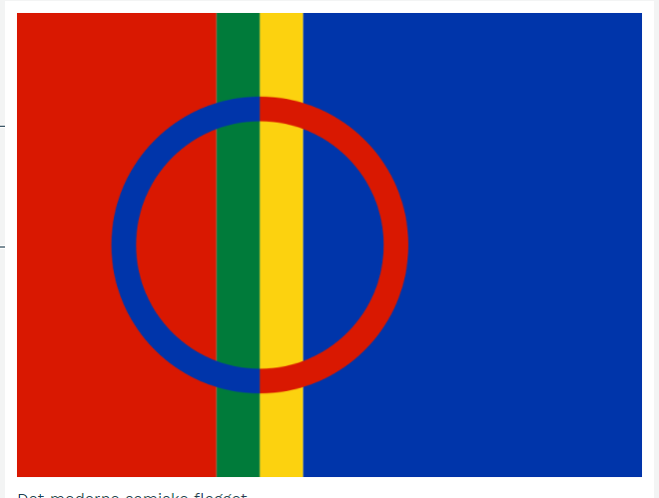  Saemiej åålmegebiejjie | 7 | 8  Ietnienbiejjie
9 | 10 | 11 | 12 | 13 | 14 | 15
16 | 17 | 18 | 19 | 20 | 21  Ietniengïelebiejjie | 22
23 | 24 | 25 | 26 | 27 | 28

BÏEJH TEEKSTEM JÏH GUVVIEM

Njoktje
Måanta | Dæjsta | Gaskevåhkoe | Duarsta | Bearjadahke | Laavvadahke | Aejlege
 |  |  |  |  |  | 1
2  Soemen saemiedigkie rïhpesovvi 1996  Fastelavenaejlege | 3 | 4 | 5 | 6 | 7 | 8  Internasjonaale nyjsenæjjaj-biejjie
9 | 10 | 11 | 12 | 13 | 14 | 15
16 | 17 | 18 | 19 | 20  Gïjrejïebnebiejjie | 21 | 22
23 | 24 | 25  Maarjanbiejjie, dovletje saemien bissiebiejjie | 26 | 27 | 28 | 29  Giesietïjje aalka  Palme-aejlege
30 | 31

BÏEJH TEEKSTEM JÏH GUVVIEM

Voerhtje
Måanta | Dæjsta | Gaskevåhkoe | Duarsta | Bearjadahke | Laavvadahke | Aejlege
 |  | 1 | 2  Skirreduarsta | 3  Guhkiesbearjadahke | 4  Påaskeiehkede | 5  Voestes påaskebiejjie
6  Mubpie påaskebiejjie | 7 | 8 | 9 | 10 | 11 | 12
13 | 14 | 15 | 16 | 17 | 18 | 19
20 | 21 | 22 | 23 | 24 | 25 | 26
27 | 28 | 29 | 30

BÏEJH TEEKSTEM JÏH GUVVIEM

Suehpede
Måanta | Dæjsta | Gaskevåhkoe | Duarsta | Bearjadahke | Laavvadahke | Aejlege
 |  |  |  | 1  Internasjonaale barkiji-biejjie | 2 | 3
4 | 5 | 6 | 7 | 8  Dåaroe orriji 1945 | 9 | 10
11 | 12 | 13 | 14  Kristusen vuelkemebiejjie | 15 | 16 | 17  Nöörjen maadthlaakebiejjie
18 | 19 | 20 | 21 | 22 | 23  Bængsta | 24  Voestes bængstabiejjie
25  Mubpie bængstabiejjie | 26 | 27 | 28 | 29 | 30 | 31

BÏEJH TEEKSTEM JÏH GUVVIEM

Ruffie
Måanta | Dæjsta | Gaskevåhkoe | Duarsta | Bearjadahke | Laavvadahke | Aejlege
1 | 2 | 3 | 4 | 5 | 6  Sveerjen nasjonaalebiejjie | 7
8 | 9 | 10 | 11 | 12 | 13 | 14
15 | 16 | 17 | 18 | 19 | 20  Jovnesåhkoeh (S) | 21  Jovnesåhkoeh-biejjie (S)  Biejjie jarkele
22 | 23  Jovnesåhkoe-iehkede (N) | 24  Jovnesåhkoeh (N) | 25 | 26 | 27 | 28
29 | 30

BÏEJH TEEKSTEM JÏH GUVVIEM

Snjaltje
Måanta | Dæjsta | Gaskevåhkoe | Duarsta | Bearjadahke | Laavvadahke | Aejlege
 |  | 1 | 2 | 3 | 4 | 5
6 | 7 | 8 | 9 | 10 | 11 | 12
13 | 14 | 15 | 16 | 17 | 18 | 19
20 | 21 | 22 | 23  Mïetskh aelkieh | 24 | 25 | 26
27 | 28 | 29  Olsohkebiejjie | 30 | 31

BÏEJH TEEKSTEM JÏH GUVVIEM

Mïetske
Måanta | Dæjsta | Gaskevåhkoe | Duarsta | Bearjadahke | Laavvadahke | Aejlege
 |  |  |  |  | 1 | 2
3 | 4 | 5 | 6 | 7 | 8 | 9  EN:n gaskenasjonaale aalkoeåålmegebiejjie
10 | 11 | 12 | 13 | 14 | 15  Saemiensaevege dåhkasjovvi 1986 | 16
17 | 18  Saemieraerie tseegkesovvi daan biejjien 1956 | 19 | 20 | 21 | 22 | 23  Mïetske orreje
24 | 25 | 26  Sveerjen saemiedigkie rïhpesovvi 1993 | 27 | 28 | 29 | 30
31

BÏEJH TEEKSTEM JÏH GUVVIEM

Skïerede
Måanta | Dæjsta | Gaskevåhkoe | Duarsta | Bearjadahke | Laavvadahke | Aejlege
 | 1 | 2 | 3 | 4 | 5 | 6
7 | 8 | 9 | 10 | 11 | 12 | 13
14 | 15 | 16 | 17 | 18 | 19 | 20
21 | 22 | 23  Tjaktjejïebnebiejjie | 24 | 25 | 26 | 27
28 | 29 | 30

BÏEJH TEEKSTEM JÏH GUVVIEM

Golke
Måanta | Dæjsta | Gaskevåhkoe | Duarsta | Bearjadahke | Laavvadahke | Aejlege
 |  |  | 1 | 2  Lappekodisillen 1751 | 3 | 4
5 | 6 | 7 | 8 | 9  Nöörjen saemiedigkie rïhpesovvi 1989 | 10 | 11
12 | 13 | 14 | 15 | 16 | 17 | 18
19 | 20 | 21 | 22 | 23 | 24  EN:n biejjie | 25  Giesietïjje nåhka
26 | 27 | 28 | 29 | 30 | 31  Healkamæssa Sveerjesne, Soemesne

BÏEJH TEEKSTEM JÏH GUVVIEM

Rahka
Måanta | Dæjsta | Gaskevåhkoe | Duarsta | Bearjadahke | Laavvadahke | Aejlege
1
Healkamæssa Nöörjesne

2 | 3 | 4 | 5 | 6 | 7 | 8  Aehtjienbiejjie
9  Soemen saemieparlameente tseegkesovvi 1973 | 10 | 11 | 12 | 13 | 14 | 15  Isak Saban reakedsbiejjie 1875
16 | 17 | 18 | 19 | 20 | 21 | 22
23 | 24 | 25 | 26 | 27 | 28 | 29  Elsa Laula Renbergen reakedsbiejjie 1877  Voestes adveente
30

BÏEJH TEEKSTEM JÏH GUVVIEM

Goeve
Måanta | Dæjsta | Gaskevåhkoe | Duarsta | Bearjadahke | Laavvadahke | Aejlege
 | 1 | 2 | 3 | 4 | 5 | 6  Soemen åålmegebiejjie  Mubpie adveente
7 | 8 | 9 | 10 | 11 | 12 | 13  Luciabiejjie  Gåalmede adveente
14 | 15 | 16 | 17 | 18 | 19 | 20  Njealjede adveente
21  Biejjie jarkele | 22 | 23 | 24  Jåvle-iehkede | 25  Voestes jåvlebiejjie | 26  Mubpie jåvlebiejjie | 27
28 | 29 | 30 | 31  Orrejaepie-iehkede

